**Project First Increment Report**

**Features developed for Increment1:**

1. Homepage
2. Login/Logout feature
3. Registration page

**Existing Services/REST API:**

[http://api2.bigoven.com/](https://www.google.com/url?q=http://api2.bigoven.com/&sa=D&source=hangouts&ust=1519531812513000&usg=AFQjCNHFS1mBbz3jSX0GrPF4H3GNBTPdbw)  
<http://developer.groceryserver.com/>  
http://www.programmableweb.com/api/smartpea-grocery/

**Detail Design of Features:**

**1.WireFrames & mockup:**

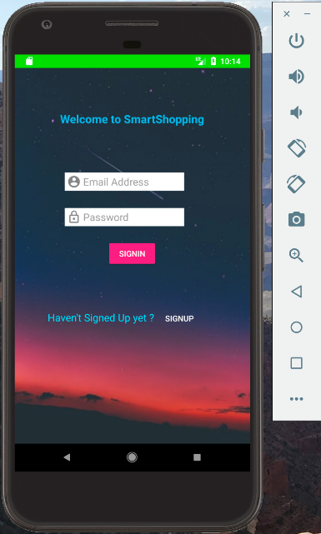 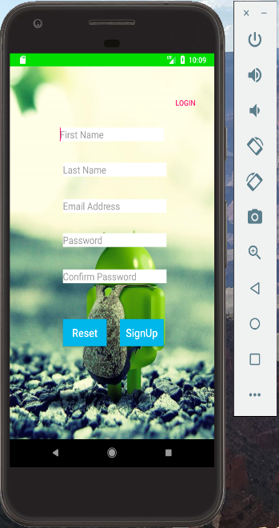 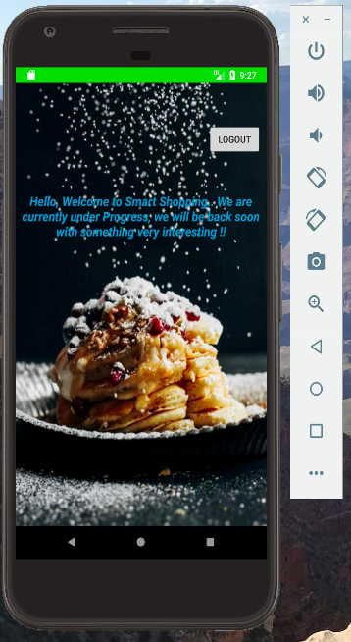

**Basic Functionality:**

When the application is installed in the mobile, user should be able to see Signin page having Email address, password fields. After providing the details and selecting signin option, user should be able to see the home page.

User needs to get registered into the application by clicking on the SignUp botton, and once registration process is completed, user can signin into the application and can do the needful.

**2.Class diagram:**

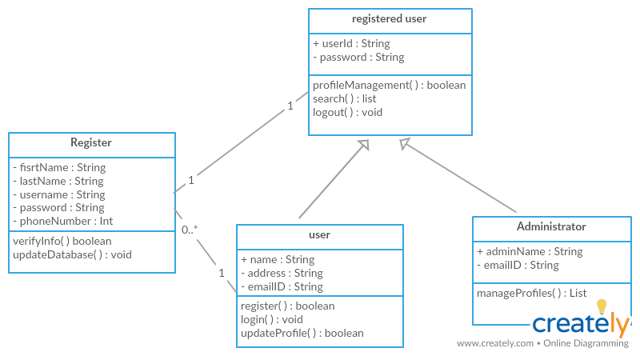

**3.User story:**

**User Story 1:**

As a user I should be able to Signin/Signup into the Smart Shopping app successfully so that I can search for any recipe and its ingredients.

**Acceptance Criteria:**

* User should be able to see the below mentioned fields once the application is opened.
* Application name title (Smart Food shopping)
* Username Text Field
* Password Text Field
* SIGN IN button
* Registration Link “For account Creation”
* Registered user should be able to enter username and password for successfully login into the application.
* An error message “Please enter valid Username and password” should get displayed when user tries to enter invalid/no value in the Username and Password Text fields.
* User should get below mentioned Fields once the register button is clicked.
* Registration form Title
* First Name Text Field
* Last Name Text Field
* Email Address Text Field
* Password Field
* Confirm Password Text Field
* Submit Button
* Reset Button
* After selecting Submit Button, User should be able to see the Signin/Signup page again and after entering the Username and Password user should be able to successfully signin into the application.
* Upon selection of reset button all the entered data should get erased from the fields.
* When user successfully signup into the application, he/she should be able to see a profile icon on the top right corner of the page. Upon selection of the Icon User should get all the profile details entered in the register form page and should be able to edit the details.
* Logout (displayed in the profile icon on the top right of the page) is used to log out from the application.

**4.Usecase diagram:**

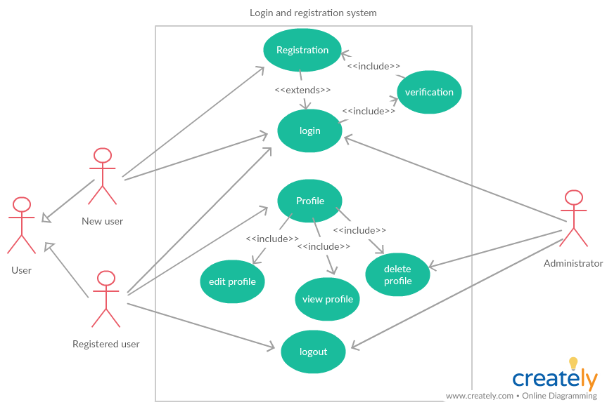

**Unit Testing:**

|  |  |  |  |
| --- | --- | --- | --- |
| 1. Unit Test Cases | | | |
| **ID** | **Test Cases** | **Input Value** | **Expected Output** |
| 1.1 | 1.Open android application and select SIGNUP button.  2. Verify that Following fields should be displayed after selecting signup button in homepage   * First Name * Last Name * Email Address * Password (dotted format) * Confirm Password (dotted format)   3. Click on reset button to reset all the text fields.  4. Enter all the valid details and select Signup button.  5. Click on login button to signIn into the app. | Enter all the valid details in the fields displayed in the register page. | User should be able to enter all the data in the register page and should successfully signup into the application. |
| 2.1 | 1. Open android application and check for the login page.  2. Enter the valid login details (Existing User Details) and click on signIn option.  3. User should be able to signIn into the application. | Enter valid username and password. | Verify that the fields are able to take the value and upon clicking the signIn button, user should login into the account. |
| 2.2 | 1. In home page logout button should be displayed in top right corner  2. Click on the logout button and verify that the signIn page is displayed | Click on logout button. | Verify that user is successfully logged out and signIn page is displayed. |
| 3.1 | In signIn page, text fields should not be empty. | Empty text fields | Error message “Fields cannot be empty” is displayed |
| 4.1 | In registration page, Password and confirm password value should be same. | 1. password and confirm password values are different | Error message  “Password and confirm password should match” is displayed |
| 4.2 | In registration page, Email should in [xxx@yy.zz](mailto:xxx@yy.zz) formate. | @ or . sysmbol is missing | Error message “Please enter valid email, Ex: [kranthi@gmail.com](mailto:kranthi@gmail.com)” is displayed |
| 4.3 | In registration page, Fields should not be empty. | Any of the field or all the fields are empty. | Error message “Please fill all the fields, fields cannot be empty” is displayed. |

|  |  |  |  |
| --- | --- | --- | --- |
| 2. Unit Test Results | | |  |
| **ID** | **Test Cases** | **Pass/Fail** | **Date Tested** |
| 1.1 | 1.Open android application and select SIGNUP button.  2. Verify that Following fields should be displayed after selecting signup button in homepage   * First Name * Last Name * Email Address * Password (dotted format) * Confirm Password (dotted format)   3. Click on reset button to reset all the text fields.  4. Enter all the valid details and select Signup button.  5. Click on login button to signIn into the app. | Pass | 2/23/2018 |
| 2.1 | 1. Open android application and check for the login page.  2. Enter the valid login details (Existing User Details) and click on signIn option.  3. User should be able to signIn into the application. | Pass | 2/23/2018 |
| 2.2 | 1. In home page logout button should be displayed in top right corner  2. Click on the logout button and verify that the signIn page is displayed | Pass | 2/23/2018 |
| 3.1 | In signIn page, text fields should not be empty. | Pass | 2/23/2018 |
| 4.1 | In registration page, Password and confirm password value should be same. | Pass | 2/23/2018 |
| 4.2 | In registration page, Email should in [xxx@yy.zz](mailto:xxx@yy.zz) formate. | Pass | 2/23/2018 |
| 4.3 | In registration page, Fields should not be empty. | Pass | 2/23/2018 |

**Implementation using Android Studio:**

Implementation of application in emulator

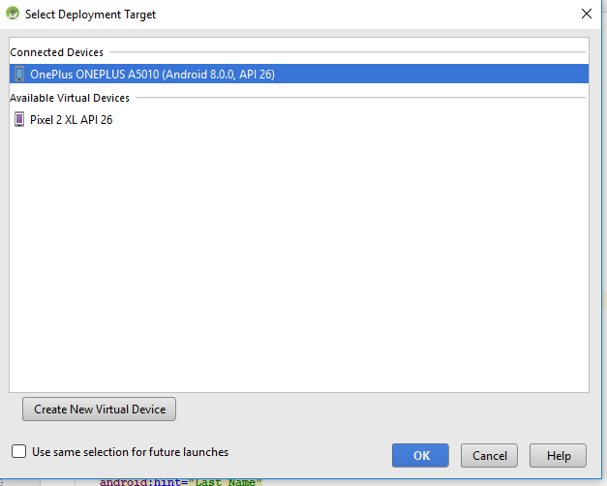

Once the application is opened in the emulator the homepage will be displayed as below:

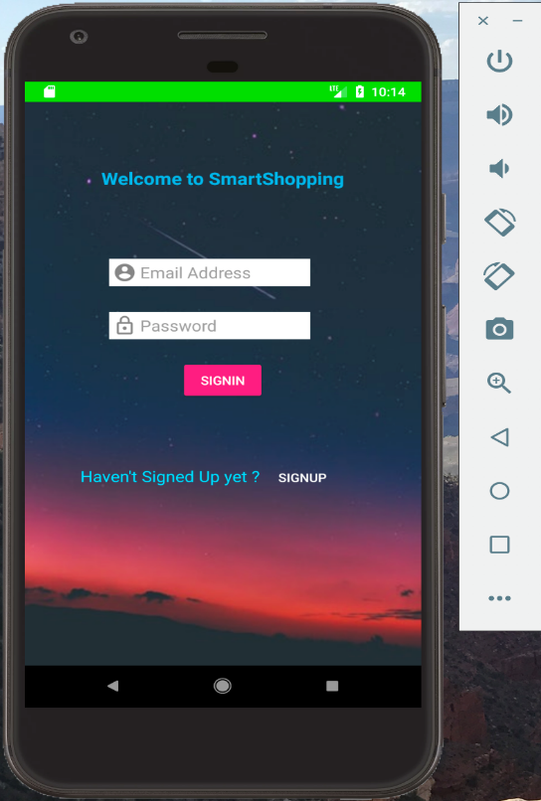

When no details are entered in the email address and password fields, then an error message will be prompted saying that “Fields cannot be empty”.

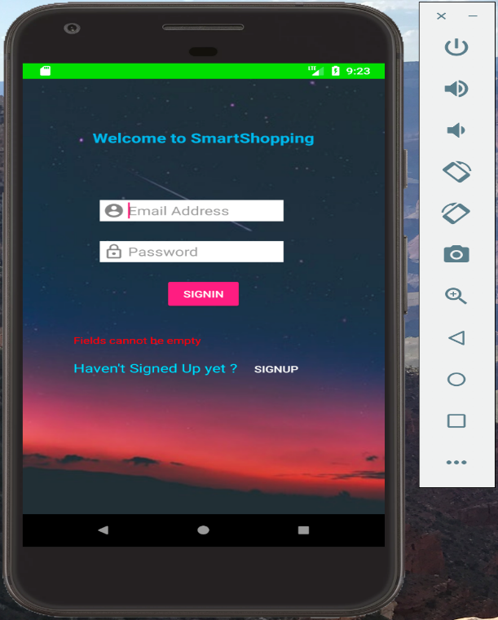

When password field/Email address fields are kept empty and tried for signing into the account, an error will be prompted saying Fields cannot be empty.

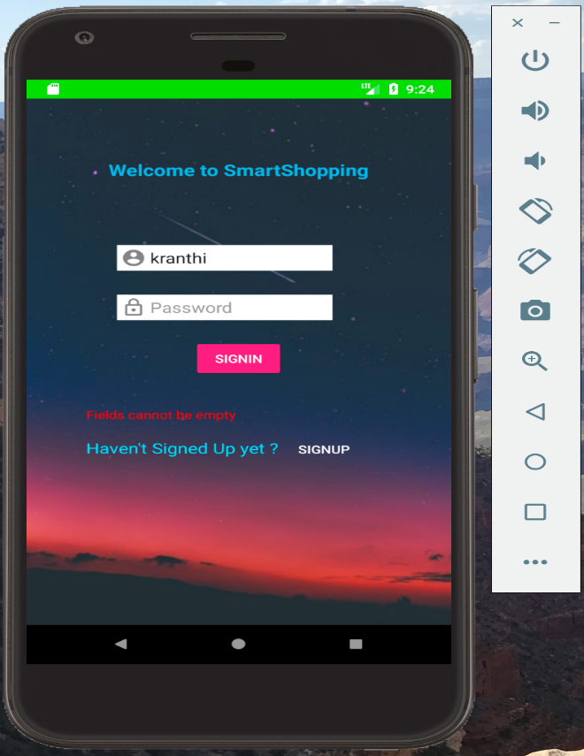

When invalid login name and details are entered, an error should be prompted saying “Invalid Credentials. Please enter valid credentials”.

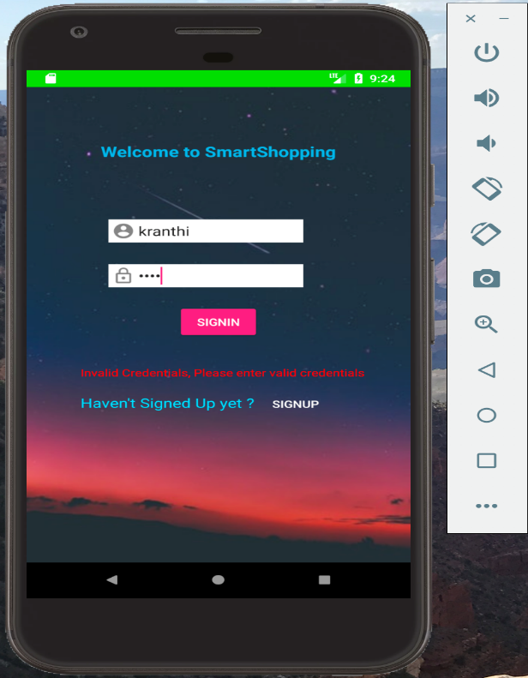

Upon Successful login. The below page is displayed.



When Signup button is clicked, register page should be displayed as below having First Name, Last Name, Email Address, Password, Confirm Password along with Reset, Signup and Login buttons.

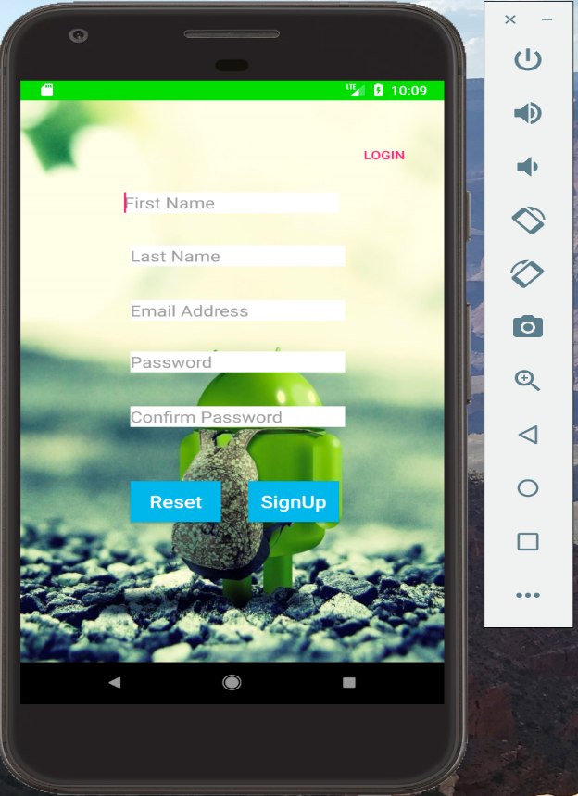

When No details are entered in all the fields, then an error should be prompted saying please fill all the fields. Fields cannot be empty.

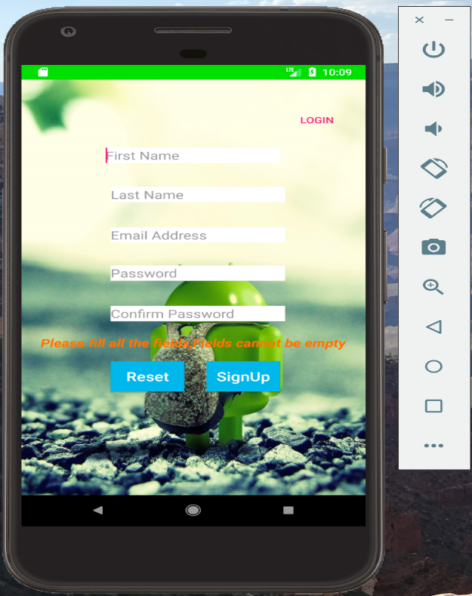

When email address is not provided in the required format i.e., without providing @xxxx.com, then error should be prompted saying that Please enter Valid Email:Kranthi@gmail.com

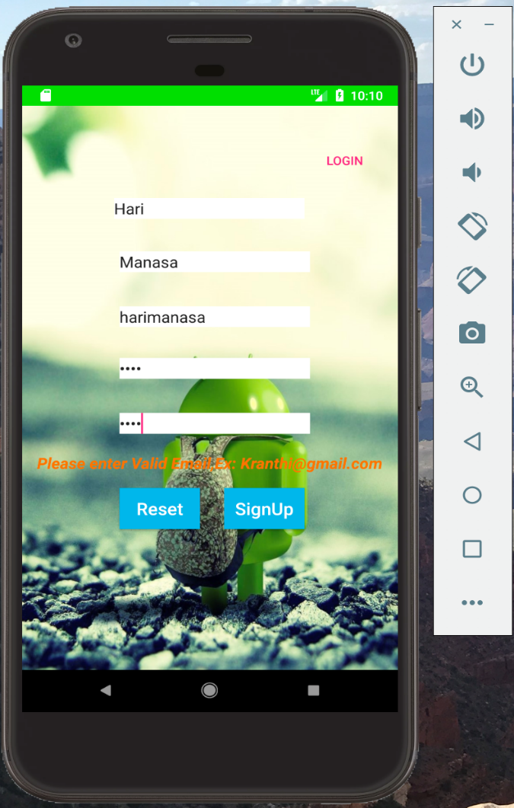

**Deployment:**

Deployed the code in an android mobile. Application has run successfully.

Please find the screen shots below:

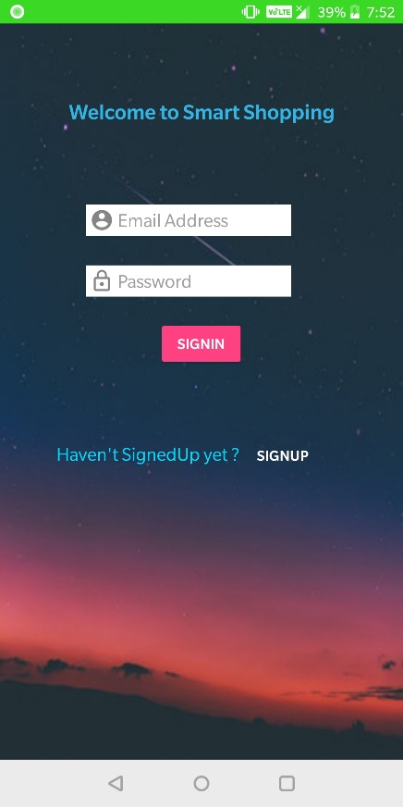 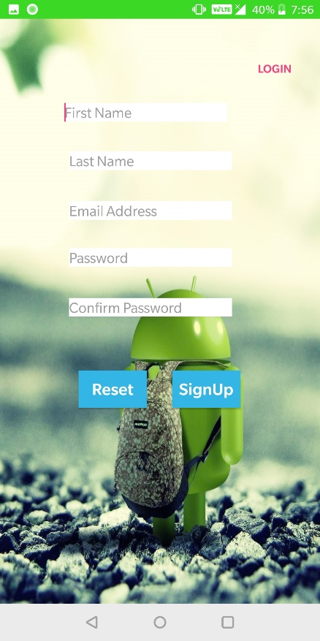 

**Please find Github Wiki below:**

<https://github.com/KranthiKumarGangineni/ASE-Project1/wiki/ASE-Project-1-Wiki>

**Project Management**

**Board Issues:**

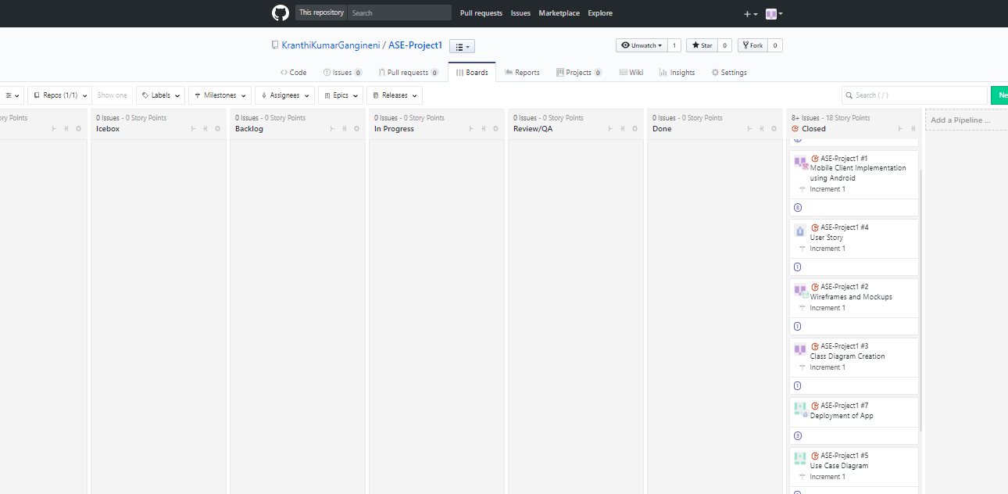

**ZenHub report:**

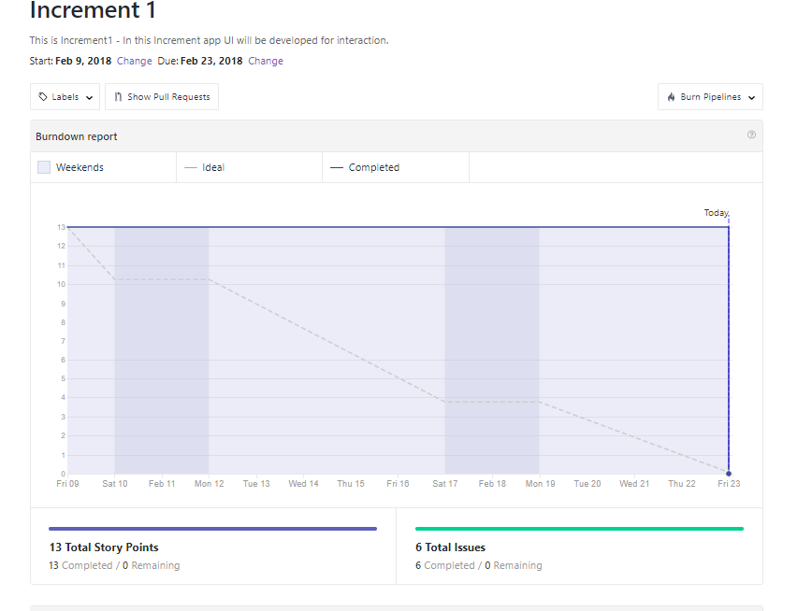

**Contribution chart :**

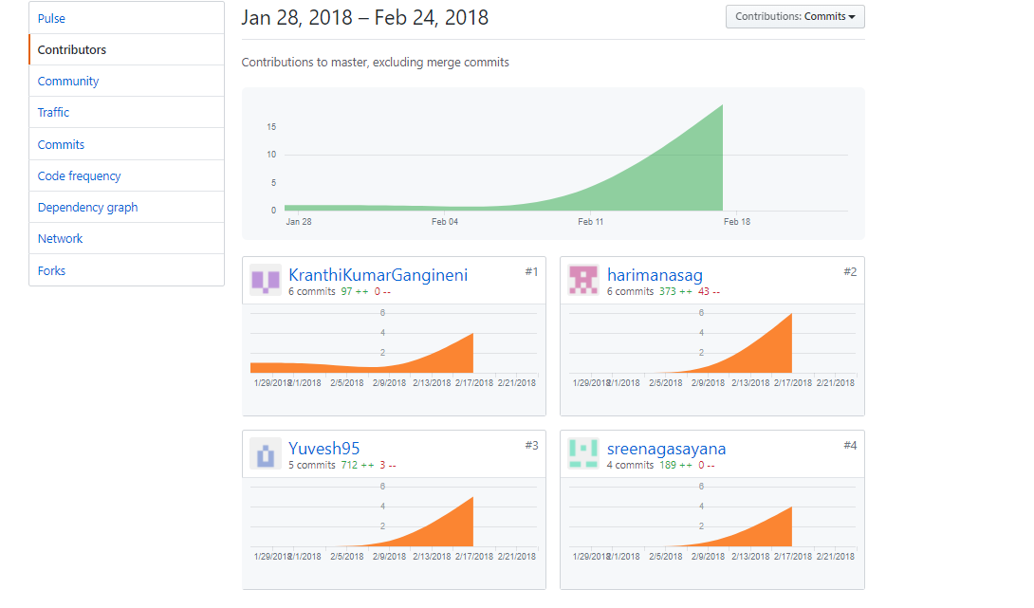

**Bibilography:**

<https://developer.android.com/>

<https://creately.com/app>

<https://www.tutorialspoint.com/uml/uml_class_diagram.htm>

http://www.yodiz.com/blog/writing-user-stories-examples-and-templates-in-agile-methodologies/